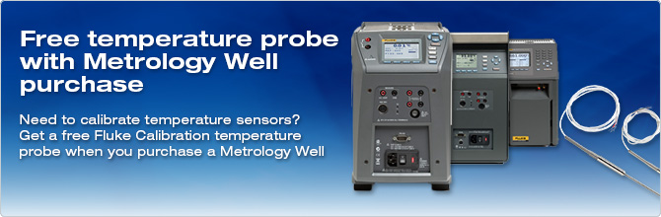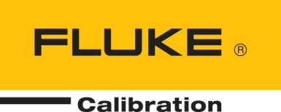

November 2nd, 2015

**Rep Alert**

**Promotion: Free temperature probe with Metrology Well purchase**

Dear Sales Partner,

Please find below all the details of a new promotion with the Fluke Calibration Metrology Wells.

**Promotion:**

Get a free Fluke Calibration temperature probe when you purchase a qualifying Metrology Well.

Qualifying Metrology Wells:

* [9142, 9143, or 9144 Field Metrology Wells (P versions only) »](http://eu.flukecal.com/9144)
* [9170, 9171, 9172, or 9173 Metrology Wells (R versions only) »](http://eu.flukecal.com/917x)
* [9190A Ultra-Cool Field Metrology Wells (P versions only) »](http://eu.flukecal.com/9190A)

Qualifying temperature probes include all Fluke Calibration temperature probes up to the value of a 5615-SLEN (EUR 1120 or equivalent list price in other currency).

**Time frame**: November 2nd – June 30th, 2016

### How to order:

### Place your order for a qualifying Fluke Calibration Metrology Well at regular list price and a qualifying temperature probe at value 0 on one purchase order. Please mention METROLOGY-WELL-PROMO on the order.

### Terms and conditions:

* This offer cannot be combined with any other discounts.
* No cash returns are made.
* This offer is only valid for customers in Europe, Middle-East, Turkey and Africa.
* Fluke reserves the right to change or withdraw the program at any time, without any prior notice.
* This offer is void where prohibited by law.

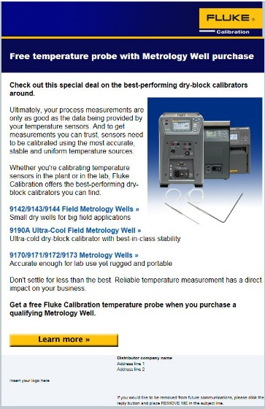

**How to promote:**

* Promotional webpage and banner on FCAL website:   
  <http://eu.flukecal.com/free-probe-with-metrology-well>
* 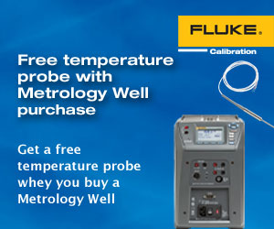Promotional banner on distributors’ websites.
* Html mail to end customers

Please notify [gerda.meijer@flukecal.com](mailto:gerda.meijer@flukecal.com) when you need the html mail and/or banner in a different size or language.

With kind regards,

EMEA Fluke Calibration Team